Java Installation

I Have shared you the java downloader right and install and follow the same procress of mysql to set the path

C:\Program Files\Java\jdk-17\bin “These is my case check you c drive for correct ”

After these install Spring Tool Suit

Spring Tool Suit  
  
<https://spring.io/tools>

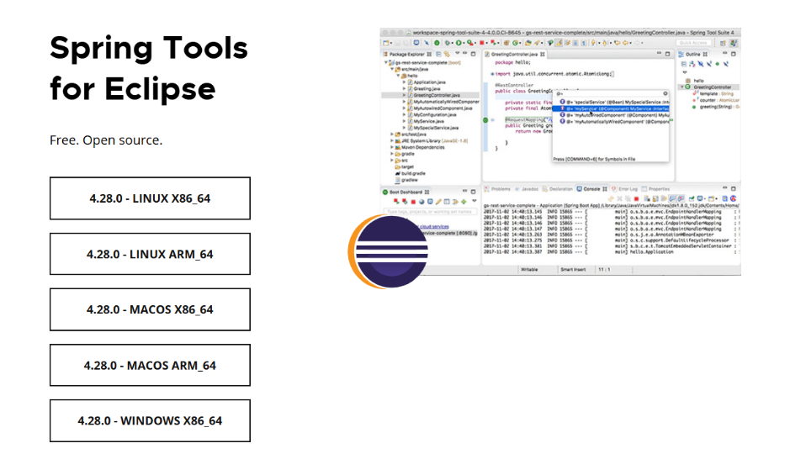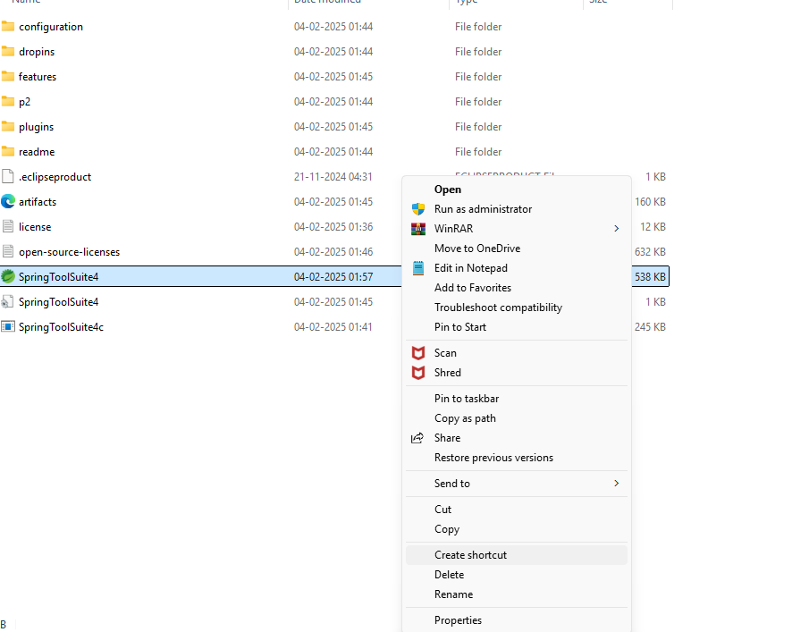

Create shortcut and paste in the desktop

Right click to open then Set the Workspace path

